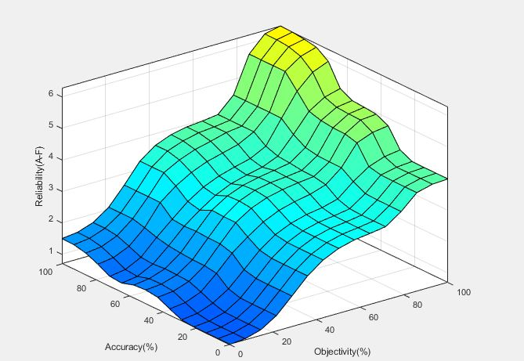

*Figure 28 gaussmf centroid*

Mamdani Type One Fuzzy Inference Systems for ranking credibility of information and reliability of information sources.

# **Introduction**

Distinguishing worthless information from reliable information, true information from false information. How to properly assess the source of information? Is the source reliable or worthless? Biased or unbiased? Assessing the validity of information is challenging but necessary, as we cannot just take someone's word for it. Mistakes, logical errors, bias, failure to recognize fallacious argumentation and manipulation, these are matters of incredible importance in the modern world, for they have extremely far-reaching implications, and at the same time, being almost completely omitted in the process of education, media coverage and political discourse.

# **Literature Review**

On February 28, 1998, Dr. Andrew J Wakefield published study report in which he showed correlation between measles-mumps-rubella vaccine (M.M.R) and autism. (Wakefield et al., 1998).

Six years later journalist Brian Deer exposes documents, leaked by Wakefield’s colleagues, showing Wakefield’s failure to disclose that, at the time of writing his report, he received substantial amount of money from solicitors representing parents of children with autism, whose primary motivation was to obtain a piece of evidence which they could then use against vaccine manufacturers. (Dominus, Susan, 2011).

The British Medical Journal concluded that Wakefield’s report was unethical and fraudulent (Godlee et al., 2011). Infamous doctor is being blamed for damage to public health linking decreasing vaccination rates to his work, as he and his work till this day remain an inspiration for the people involved with the anti-vaccine movement (Dominus, Susan, 2011).

Andrew had his medical license revoked by the General Medical Council and his paper was retracted by the publisher (Dominus, Susan, 2011).

An extensive evidence-based meta-analysis of case-control and cohort studies involving 1,256,407 children from 2014 reveals no evidence of relationship between vaccination and autism. (Taylor et al., 2014).

Meta-analysis from 2009 reveals people’s tendency to become biased towards certain information based on the state of knowledge of individual, pre-existing beliefs (Hart et al., 2009). We tend to assume quicker that information is true if it matches our already existing set of beliefs or behaviors, supports or corelate with our goals (Hart et al., 2009).

We also tend to in a sense pursue the feeling of validation, by selecting information sources which align with our goals. The research notes two primary motivations of searching for information, motivation to feel validated and motivation to gain an accurate understanding of reality. (Hart et al., 2009). There is a danger when researcher’s motivation is solely to feel validated (Hart et al., 2009). Accuracy motivation can help with accurate perception of reality, defense motivation promotes self-validation (Hart et al., 2009).

There are two forms of biases very well recognized by the field of psychology, a subtle bias and a blatant bias (Susan and Fiske, 2002). Susan writes that most of us reveal unconscious bias. Our minds do it automatically, people have tendencies to favor some information above others if that information aligns itself with our sense of belonging to a group of people, naturally the addiction of feeling validated creates tendency in people to seek out more information that would validate our views further and avoid or downright discard arguments that would challenge it (Susan and Fiske, 2002).

Susan writes that people typically are on the automatic lookout for authorities, if they feel comfortable with a certain person, either because person looks or talks like them, or maybe their arguments reflect what they’ve been thinking themselves, regardless of fact being true or false, then this person will start perceiving himself as a member of this in-group (Susan and Fiske, 2002). This person will also start to categorize others based on their opinions, often showing hostility towards groups of people with different views and opinions about the state of matters (Susan and Fiske, 2002).

These preconditions can give a platform for discriminatory behaviors or hate crime in case of subtle bias, and extremism in terms of blatant bias (Susan and Fiske, 2002). Susan mentions that factors such as education, economic opportunity, intergroup interactions may reduce both subtle and blatant biases in individuals (Susan and Fiske, 2002).

The Website article “How to Argue Against Common Fallacies” written by Tim Dare from University of Auckland, describes three categories of most common fallacies, Fallacies of Relevance, Fallacies of Unacceptable Premises, and Formal Fallacies. (Tim Dare, 2022)

Fallacies of Relevance happen when a reason is given for believing certain claim or conclusion, but the reason being false or having no correlation with the actual truth. Examples include but are not limited to:

* Tu Quoque Fallacy – “Who are you to talk?”.
* The Red Herring Fallacy – Where arguer sidetracks his audience by raising irrelevant issues and then claims that original problem has been settled by the irrelevant diversion.
* Ad Hominem – “At the person” fallacy. Rejecting an argument by attacking the person rather than evaluating the argument on its merits.
* Fallacious Appeal to Authority – adopting a view simply because someone who we regard as authority told us to.
* Argumentum Ad Ignorantiam – Claim must be true because no one has proven it is false.
* Appeals to Emotion – Where the arguer attempts to inspire feelings, even if they’re not logically relevant to the writer’s claim or conclusion. (Tim Dare, 2022).

Fallacies of Unacceptable Premises may introduce relevant arguments, while the arguments still don’t support conclusion of the argument. Examples of that include:

* False Dilemma / False Dichotomy – happens when two options of arguments are proposed, which gives the impression that only one of them may be true, and no other arguments exist

(Tomic, 2013).

* Decision Point Fallacy / Sorites Paradox – arises in certain conditions where a term is used to describe state of things where there doesn’t exist an accurate definition of whether the term used applies to circumstance. An arguer claims that because of inability to identify a precise boundary or decision point, we cannot distinguish between correct and incorrect usage of the term. (Tim Dare, 2022).

Formal Fallacies happen where arguments are fallacious not because of their content but because of their form or structure. A quick example:

* Affirming the consequent – Assumption of “I have a dog, he will bark where there is an intruder” gives raise to false conclusion “The dog is not barking, there’s no intruder”.
* Denying the Antecedent – “If it barks, then it’s a dog, it’s not braking therefore it isn’t a dog”.

Tom Quiggin In his research notes from 2013, writes about responsibility that comes with publishing an academic paper, pointing out that such resources may be used in court proceedings, influencing the decision of the jury. Tom describes difficulties researchers will face when exposed to certain pieces of information, no track record, false information. Assessing credibility of source is especially difficult on the web or when information doesn’t come from academic environments.

Being popular doesn’t make you a reliable source of information (Quiggin, 2013). Caution is advised when considering using newspaper articles as sources, as those organizations are often biased and motivated by revenue and not objectivity (Quiggin, 2013).

Quoting source of information is insufficient, Tom advises to use “A1-E5” methodology for assessing veracity of information. First to investigate the source of information, track record of a person, organization or in other words author of the information on a scale from A to E, where A is a high reliability and E where the reliability is unknown, and second, to investigate the information itself, validity, strength of argument on a scale from 1 to 5 where 1 is highly credible information and 5 where there is no way information can be confirmed (Quiggin, 2013).

The paper of the conference proceedings of IEEE International Congress on Big Data in 2015 titled “Towards Automatic Veracity Assessment of Open-Source Information” proposes theoretical framework for veracity assessment automation (Lozano et al., 2015). The conference proceedings put a spotlight on the importance of quality and trustworthiness of data in Big Data (Lozano et al., 2015). The paper explores the long tradition within military domain of dealing with information, NATO STANAG 2511, research focus is to find ways to automate veracity assessment of open-source information ONSIF (Lozano et al., 2015).

NATO Standardization Agreements (STANAG) and its updated version 2511 describes a ranking system for assessing intelligence reports, writes (Lozano et al., 2015). The source reliability is denoted with a letter in a range A-F, A – Completely reliable, B - Usually reliable, C - fairly reliable, D – Usually unreliable, E - Unreliable, F - Reliability cannot be verified. Then the information itself is classified with a number in the range 1 - 6. 1 – Confirmed by other sources, 2 - Probably true, 3 - Possibility of truth, 4 – Doubtful information, 5 - Improbable, 6 - Truth cannot be verified (Blasch et al, 2013).

What does it even mean that information is reliable? (Lozano et al., 2015). Performed interviews with people of various experience of using NATO STANAG 2511 in the field, when asked what they pay attention to when assessing source of information, they answer: accuracy and correctness, objectivity, reliability, traceability and provenience. When asked the same question about credibility, their answers were similar writes (Lozano et al., 2015). From the interview (Lozano et al., 2015). we’re told that reliability of source impacts credibility of information, meaning that good source rated A usually produced good quality information in credibility range 1-3, while bad source rated E produces information with lower credibility.

It's worth noting that an A5 information would be rated higher value than a E1 information (Lozano et al., 2015). Meaning that the interview respondents assign more weight to the source. An improbable information from reliable source would be held in higher regard than information coming from unreliable source, even when information itself seems more probable. The respondents bring to attention the need for information traceability. The need to establish who is the real source of the information is logical as respondents believe that source reliability affects information credibility (Lozano et al., 2015).

When asked how they would go about assessing independence of the source, the answers were to verify if a source is an originator of the information or just relaying it, check the history and associations of a source and continue to follow it continuously. Lozano writes that there is a lot of room for interpretation of NATO scales. The conference paper concludes that veracity assessment’s dominating issues are time required for assessing a source, task usually performed manually, and number of available sources, hence the need for automation (Lozano et al., 2015). It also mentions assessments being subjective in nature, there’s ambiguity and fuzziness when it comes to assessment methods. (Lozano et al., 2015).

Several authors identify underlying issues with NATO STANAG 2511, the summary of challenges with this method is ambiguity, undefined situations, imprecise definitions (Lozano). There isn’t any guidance on how to determine reliability and credibility of information, how to distinguish a completely reliable source from just reliable source is also not defined. All grades created using this methodology are purely subjective (Lozano et al., 2015). The methodology is open for interpretation, researchers from around the world proposing different variations of the methodology e.g., by adding extra factors such as likelihood and analytical confidence (Lozano et al., 2015).

Fuzzy logic mimics the human mind’s ability to reason about the world in approximates rather than exact (Zadeh, 1994). It helps the machine to infer knowledge despite uncertainty by modeling vagueness, without the need for developing complex mathematical models. It can achieve this by simulating human tolerance for uncertainty (Zadeh, 1994).

# **Discussion**

There exist many obstacles in our way to properly assess the validity of information, cognitive errors, failure to identify fallacious arguments, errors of logic, lack of knowledge in a particular subject, inability to properly assess the source of information. These obstacles affect all of us daily, influencing our ability to reason about the world, skewing our understanding about the state of matters. Methodologies such as NATO STANAG 2511 can be used to classify the source and strength of the information and rate its source.

The main issue of this methodology is that it uses vague factors and definitions of procedures, it is typically implemented manually, it relies on the ability of the human brain to reason about the world and make decisions in face of complexity and uncertainty. Assessing if information sources are reliable and information credible comes with another challenge, it's the lack of accurate model of the concept “reliable” and “credible”. Fuzzy logic may be able to address the issue of vagueness in NATO STANAG 2511 methodology.

# **System Overview**

The NATO STANAG 2511 is an unclassified NATO intelligence report, describing methodological approach for assessing reliability of human as a source of information and credibility of the information presented by this source. A fuzzy inference system could be designed to automate reliability and credibility assessment.

Reliability of the source can be ranked by paying attention to:

* Accuracy, describing how often our source provides credible information. For example, 9 out of 10 claims made by source were validated, confirmed, and proven true. This means the accuracy of the source is 90%. This input can be a good indicator of reliability of source but it’s not the strongest one, the reasoning is that even highly accurate sources can make mistakes. Every single piece of information should be approached equally with caution.
* Objectivity, imagine we’re given a percentage value reflecting source objectivity, how we get about finding this value resides beyond my capabilities and scope of this coursework it would have to involve the assessment of personal associations and motivations of that source.

Credibility of information can be determined by factoring in:

* Validations, how many other information sources support presented information. How strong is the correlation of information coming from various sources?
* Reliability of source, the idea is that reliability of sources affects the credibility of information. This means that reliability of source should be assessed first.
* Our gut. The issue is that the decisions need to be made even though we don’t have sufficient information, often, it’s impossible to gather sufficient information. Fallacious arguments or manipulation may also not be immediately apparent, and despite that the decisions still need to be made, therefore we’ll have to go with our gut!

The fuzzy inference system should have 2 outputs, the first being a letter in range from A-F which value will be indicative of reliability of the source of information, I shall call this output “reliable”. The second output will be a number in the range 1-6 which will indicate credibility of information, I shall call this one “credible”.

The two outputs, for example “reliable” = B and “credible” = 4 will be then concatenated to form the classification grade “B4”, which carries a meaning that source of information is “B - Usually reliable” but this piece of information provided by that source was “4 - Doubtful”.

I decided to split the fuzzy inference system into two.

# **Design details**

In the root of the folder there is a rel.m script containing:

Mamdani Type One Fuzzy Interference System for assessing reliability of source “rel”.

Inputs of the Fuzzy Inference System “rel” (See Appendix A1).

1) “Accuracy” (%), Fuzzy sets:

* low,
* medium,
* high.

2) “Objectivity” (%), Fuzzy sets:

* weak,
* medium,
* strong.

The single output of the Fuzzy Inference System “rel” (See Appendix A2).

“Reliability” (A-F), Fuzzy sets:

* A – Completely reliable,
* B - Usually reliable,
* C - fairly reliable,
* D – fairly unreliable,
* E – Usually unreliable,
* F – Completely unreliable.

The definitions of classes differ slightly from the ones specified in NATO STANAG 2511.

This system takes in dummy data for the inputs from the excel spreadsheet “NATO_STANAG_2511.xlsx”. Column A for Objectivity (%), column B for Accuracy (%). it outputs a floating-point crisp value to the column F.

As for the Accuracy input, I attempted to make it symmetrical, anything below 50% gradually belongs more and more to the low accuracy set, anything above 50%, to the high accuracy set, I decided 35 and 75 to be the medium, where accuracy of 50% would result in degree of membership of 1 to the fuzzy set medium.

The objectivity input is not symmetrical. Anything above 70% objectivity results in a gradually greater degree of membership to fuzzy set strong. Anything below 85% and above 30% in my opinion is medium credibility, below 60% objectivity is gradually weakening. My configuration leaves very little room for bias.

The Reliability (A-F) outputs a value on a scale from 0 to 7. Any value less than 1 will result in a degree of membership of 1 to the fuzzy set F. Any value higher than 6, to the fuzzy set A.

The rule base for “rel” (See Appendix A3). We cannot assign A to the source if the objectivity is not strong. Weak objectivity jeopardizes reliability score. The rule base functions as follows, objectivity dictates to which half of the 6 sets reliability will belong to, weak objectivity will result in F, E, D. Higher objectivity in C, B, A. Then the accuracy will weigh on which exactly set in that half will be the final score. Higher accuracy will push the final grade up the ladder, and lower accuracy will pull it down. With medium objectivity, the source’s accuracy determines whether output is D or C, lower middle or upper middle.

Defuzzification method of choice is centroid. Here were using min for the And method, max for Or method, min for implication and max for aggregation.

The output float value is then used as input to the fuzzy inference system “cred”

In the root file of the folder there is a cred.m script containing:

Mamdani Type One Fuzzy Inference System for Assessing credibility of information “cred”.

Inputs of the Fuzzy Inference System “cred” (See Appendix B1)

1) “Validations” (0-10), Fuzzy sets:

* low,
* medium,
* high.

2) “Reliability” (A-F), Fuzzy sets:

* A – Completely reliable,
* B - Usually reliable,
* C - fairly reliable,
* D – fairly unreliable,
* E – Usually unreliable,
* F – Completely unreliable.

3) “Gut feeling” (%) Fuzzy sets:

* negative,
* neutral,
* positive.

The single output of the FIS “cred” (See Appendix B2).

“Credibility” (1-6), Fuzzy sets:

* 1 – Confirmed by other sources,
* 2 - Highly Probable,
* 3 - Possible,
* 4 – Doubtful,
* 5 - Improbable,
* 6 - cannot be verified,

The definitions of classes are unchanged from the ones specified in NATO STANAG 2511.

This system takes dummy data for the inputs from the same excel file “NATO_STANAG_2511.xlsx”. Column H for Validations (0-10) input, column I for Gut (%) input, and column F for Reliability (A-F) input which was automatically generated by FIS “rel”. The system outputs a crisp value in the range 0-7 to the column K. (See Appendix)

As for the Validations (0-10) input, if something is repeated once or twice then it's probably nothing, if its three or more, then it’s probably worth checking. However, I decided that my system should give extra benefit of the doubt, putting the middle point at 5. If the information was validated by more than 5 sources, then the value of validations is high, below 5 it gradually becomes low. I decided 5 to be the medium point, If the validation is 5 then the degree of membership to the fuzzy set medium should be 1. The sets are fuzzy to address the vagueness associated with variability of reliability of those other sources.

The configuration of input Reliability (A-F) is the same as the output Reliability (A-F) of the FIS “rel”. I couldn’t think of a reason why it shouldn’t be.

The gut feeling input is symmetrical. 50% gut feeling results in completely neutral state, anything above 50% linearly increases degree of membership to the fuzzy set positive etc.

The credibility output is modeled exactly the same as reliability output of FIS “rel”, the only difference being that its inverted. In reliability output score 1 would negatively impact the reliability grade, but in credibility that’s the highest score.

The rule base for “cred” (See Appendix B3) counts 19 rules. The justification of the first 6 rules is as follows, if our information cannot or is not validated by other sources then the only other indicators of credibility will be the reliability of the source itself and how we feel about the information. If our information has been validated by many sources, then it shouldn’t really matter if the source itself was unreliable, our gut is also not important in this case. Most of the rules that make use of Reliability input have their weights pulled down to 0.5. This puts emphasis on the validations input, making it the most important one. The NATO definition of grade 1 “confirmed by other sources” implies that it is the most important factor. In case of low validation, reliability and the gut play tug of war when one of those values in low and the other high, and they complement each other when both sets have similar state e.g., “there’s nobody who could confirm the information to be true, I have a bad feeling about this”.

Defuzzification method of choice is centroid. Here were using min for the And method, max for Or method, min for implication and max for aggregation.

# **Testing & evolution of the system**

When I initially was presented with the task assigning crisp boundaries to my sets, I set them up manually in MATLAB fuzzy designer, and then copied & pasted the parameters into .m scripts. The graphical user interface tool makes it easy to tweak with all the parameters of the system. After that, I made gut decisions consistently throughout the whole process of developing the initial configuration and startup rule base.

Originally, I planned to include another input for FIS “cred”

“Argumentation”, ultimately what makes for sufficient argumentation to convince us something is true, is purely subjective, differs with every individual human being. In an academic environment any conclusion, claim, statement is required to be backed by valid argumentation, a reference.

However, I concluded that its vagueness is already captured by the input gut. Gut will tell us how we feel about the strength of the argument. This modification helped me to simplify the FIS without losing quality.

Designing a rule base turned out to be quite a challenge, I tried to capture all the output scenarios by synthesizing sentences in my head. The logic of the sentences was dictated by the assumptions I’ve made about how the system should behave. They reflect my knowledge about the domain of the problem.

The number of fuzzy sets made it hard to reason about the system, I decided to simplify the gut feeling input, my initial idea was 5 fuzzy sets strong negative, negative, neutral, positive, strong positive. Now it's only negative, neutral and positive.

At the end deleting one input and simplifying another, helped to significantly reduce the complexity of the whole system.

Initially FIS “rel” had just 9 rules, and FIS “cred” started with 13 rules.

FIS “rel” is not too complicated, my initial rule base performed well, the only modifications to the rule base were adding rule 8 and 11, which puts even greater emphasis on objectivity. Initially I planned to use NOT operator on the “strong” set, reasoning was that if objectivity is not strong, then the output value is lowered, however it resulted in too great of a pull every time objectivity was medium. Instead, I decided to handle “weak” and “medium” cases separately which allowed for more controlled pullback.

I modified a piece of code provided in coursework resources to test all defuzzification methods in one go and save the output of each to xlsx file with a name corresponding to the .m script name (See Appendix C1). This automation allowed me to focus more on experimenting with all the other parameters of both fuzzy inference systems.

A total of 6 test scripts were prepared for the fuzzy inference system “rel”.

In the rel_tests folder there is a “rel_test_data.xlsx” file which contains 26 entries, each entry is a different arrangement of objectivity and accuracy values, there’s also a guide of expected rel outputs. The expected values are just for the reference, they were added manually and they may be slightly different from the final result. As long as the deviation is not big enough to assign C where expected was E then we should be fine. Ranking the source as D where the expected output was E is acceptable. (See Appendix D1)

In the rel_tests folder there are also 6 subfolders, each containing .fis config file, .m script file, and the excel file, all with corresponding names. Every excel file contains output values for all defuzzification methods.

rel_tri folder contains script to test FIS “rel” configured using only triangular membership functions. (See Appendix D2).

rel_trap folder contains “rel” configured using only trapezoidal membership functions. (See Appendix D3).

rel_gauss folder tests configuration of gaussian membership functions (See Appendix D4).

rel_gbell tests configuration of generalized bell-shaped mf. (See Appendix D5).

rel_pointy_mixed tests configuration of triangular and trapezoidal membership functions mixed together. (See Appendix D6).

rel_smooth_mixed tests configuration of bell-shaped and gaussian mf mixed together. (See Appendix D7).

The performance of each configuration differs only slightly, I’ve chosen the rel_smooth_mixed configuration to be the final configuration of the fuzzy inference system “rel”. Out of all defuzzification methods the center of gravity gives best, most predictable results in every tested configuration. The difference between centroid and bisector output values is not too significant. LoM, SoM and MoM each give confusing results, spiky surface plots reflect that.

A total of 3 test scripts were prepared for the fuzzy inference system “cred”.

The cred_tests folder has similar structure as the rel_tests. The test data every test script is using comes from the “NATO_STANAG_2511_test.xlsx” file in the root of cred_test folder. The final configuration of input reliability has already been tested and decided while testing FIS “rel”. The output credibility is modeled in the same way as reliability, which made the testing job little bit easier as the only inputs I had freedom to experiment with were validations and gut (See Appendix E1).

cred_tri folder tests for validation and gut inputs configured purely using triangular membership functions (See Appendix E2).

cred_gauss folder tests for gaussian mf. (See Appendix E3).

cred_pointy_mix folder tests for mixed triangular and trapezoidal membership functions. (See Appendix E4).

It doesn’t make sense to me to test purely trapezoidal or purely bell-shaped mfs, because both in validation and gut inputs I’m trying to capture the medium point. Smooth incline and decline of a gaussian mf work really well with the validation and gut inputs. Similarly, as with the “rel”, the centroid defuzzification method works best for the configuration and its rule base. The bisector, LoM, SoM and MoM defuzzification methods all give results which are way off the mark.

I’ve decided the cred_gauss test script to be the final configuration of fuzzy inference system “cred”.

# **Reflecting on the project**

I knew that I made a mistake when my literature review has taken me into rabbit hole of psychology, I did not feel comfortable in this field at all, and very soon I started to regret that I haven’t chosen to develop something that lies within the scope of my interests. I’m also not too good at writing literature reviews. I decided however to push through it as a way of challenging myself, the idea seemed original and addresses important issue.

My system is basic, there’s a mountain of improvements and changes to be made to make it feasible to use in real life. The issue also is that my system makes use of fake, made-up inputs. Finding out the crisp value of a person’s objectivity could be an interesting fuzzy logic project on its own, for the purpose of this project I just assumed that such system could potentially exist and output percentage value.

Both FIS “rel” and “cred” total count of rules is 30, I suspect it’s not many, the reason why rule base is so low may be the use of NOT operator, which captures multiple scenarios at once, reducing the number of necessary rules.

At the end both fuzzy systems produce numeric floating-point values, the only remaining thing to do is to assign appropriate letter to the reliability grade and concatenate it to the credibility value to get our final grade. I tried to write a switch statement that would do it, but MATLAB is weird and didn’t let me.

When using fuzzy logic designer GUI tool, every time when I exported the .fis file, I wouldn’t be able to import it back straight away. It’s a text file containing fuzzy designer configuration. When inspecting the file you can see that when it comes to input declaration, the syntax is incorrect. While exporting, the fuzzy logic toolbox export function will slice name of the input and start writing the next line in its place. Like this: ‘Objectivity(Range=[0 100]… where there should be ‘Objectivity(%)’ Range=[0 100]. Every time I had to edit text file manually.

# **Conclusion**

This report proposes a system for assessing credibility of information and reliability of source using fuzzy logic. The fuzzy inference system attempts to mimic veracity assessment methodology specified in unclassified NATO intelligence report from 2003. This report proves that such system could be implemented, but in order to make it practical, fit for use in real life, a lot more improvements and research are needed. In the appendices I’ve included all the test results, and all system configurations.

# **References**

Blasch, E., Laskey, K.B., Jousselme, A., Dragos, V., Costa, P.C.G. and Dezert, J. (Jul 2013) *URREF reliability versus credibility in information fusion (STANAG 2511).*ISIF ( Intl Society of Information Fusi, pp. 1600.

Dominus, S. (2011) 'The Denunciation Of Dr. Wakefield.(Andrew Wakefield)', *The New York times magazine,*.

Fiske, S.T. (2002) 'What We Know Now about Bias and Intergroup Conflict, the Problem of the Century', *Current directions in psychological science : a journal of the American Psychological Society,*11(4), pp. 123-128. doi: 10.1111/1467-8721.00183.

Godlee, F., Smith, J. and Marcovitch, H. (2011) 'Wakefield’s article linking MMR vaccine and autism was fraudulent', *BMJ,*342, pp. c7452. doi: 10.1136/bmj.c7452.

Hart, W., Albarracín, D., Eagly, A.H., Brechan, I., Lindberg, M.J. and Merrill, L. (2009) 'Feeling Validated Versus Being Correct: A Meta-Analysis of Selective Exposure to Information', *Psychological bulletin,*135(4), pp. 555-588. doi: 10.1037/a0015701.

Lozano, M.G., Franke, U., Rosell, M. and Vlassov, V. (2015) *Towards Automatic Veracity Assessment of Open Source Information.*IEEE, pp. 199.

Quiggin, T. (2013) 'Sources and Information in Academic Research: Avoiding Mistakes in Assessing Sources for Research and during Peer Review', *Perspectives on terrorism (Lowell),*7(1), pp. 103-111.

Taylor, L.E., Swerdfeger, A.L. and Eslick, G.D. (2014) 'Vaccines are not associated with autism: An evidence-based meta-analysis of case-control and cohort studies', *Vaccine,*32(29), pp. 3623-3629. doi: 10.1016/j.vaccine.2014.04.085.

Tim Dare *How to Argue Against Common Fallacies.*Available at: <https://www.futurelearn.com/info/courses/logical-and-critical-thinking/0/steps/9131> (Accessed: 22/12/2022)

Tomic, T. (2013) 'False Dilemma: A Systematic Exposition', *Argumentation,*27(4), pp. 347-368. doi: 10.1007/s10503-013-9292-0.

Wakefield, A., Murch, S., Anthony, A., Linnell, J., Casson, D., Malik, M., Berelowitz, M., Dhillon, A., Thomson, M., Harvey, P., Valentine, A., Davies, S. and Walker-Smith, J. (1998) *RETRACTED: Ileal-lymphoid-nodular hyperplasia, non-specific colitis, and pervasive developmental disorder in children.*Elsevier Ltd. Available at: <https://www.thelancet.com/journals/lancet/article/PIIS0140673697110960/fulltext> (Accessed: 22/12/2022).

Zadeh, L. (1994) 'Fuzzy logic, neural networks, and soft computing', *Communications of the ACM,*37(3), pp. 84. doi: 10.1145/175247.175255.

# **Appendices**

# **Appendix A1.**

## rel fuzzy inputs

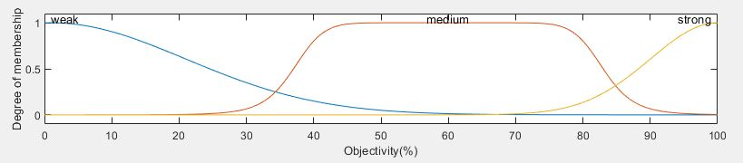

Figure 1 fuzzy input Objectivity (%)

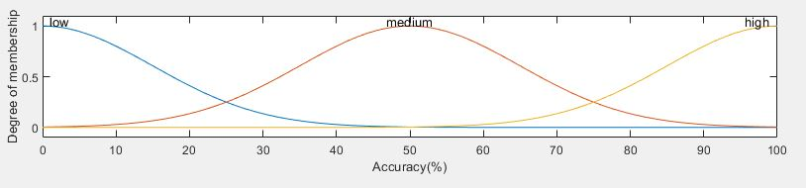

Figure 2 fuzzy input Accuracy (%)

# **Appendix A2.**

## rel fuzzy output

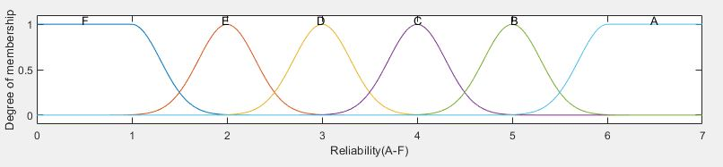

Figure 3 output Reliability (A-F)

# **Appendix A3.**

## Rules of fuzzy inference system rel

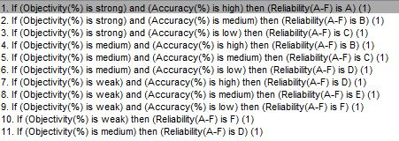

Figure 4 rel rule base

# **Appendix B1.**

## cred fuzzy inputs

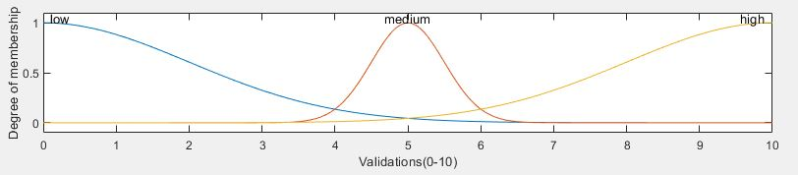

Figure 5 fuzzy input Validations (0-10)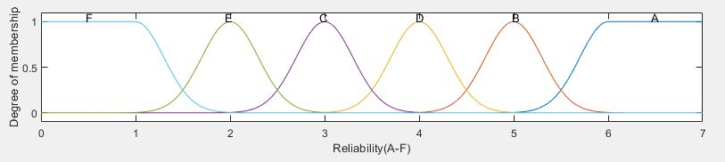

Figure 6 fuzzy input Reliability (A-F)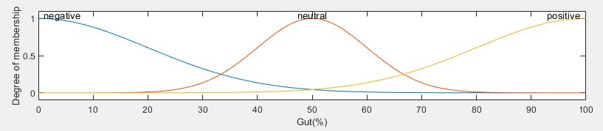

Figure 7 fuzzy input Gut (%)

# **Appendix B2.**

cred fuzzy output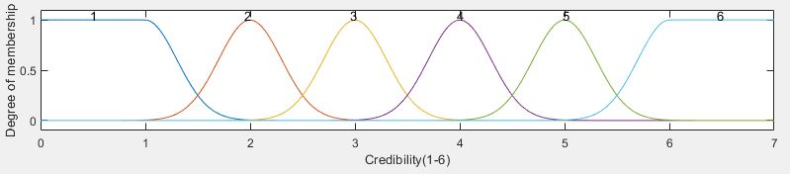

Figure 8 fuzzy output Credibility (1-6)

**Appendix B3.**

## Rules for fuzzy inference system cred

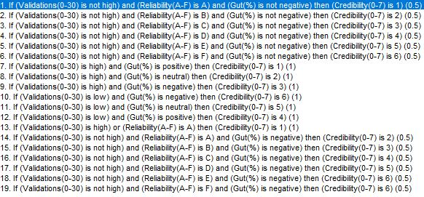

Figure 9 cred rule base

# **Appendix C1.**

Automation of testing defuzzification methods 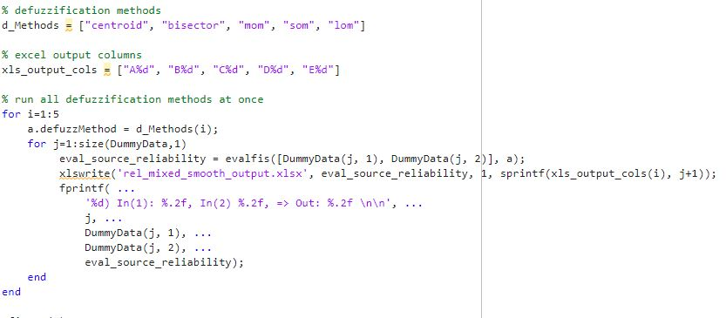

Figure 10 automation script

# **Appendix D1.**

## rel test data

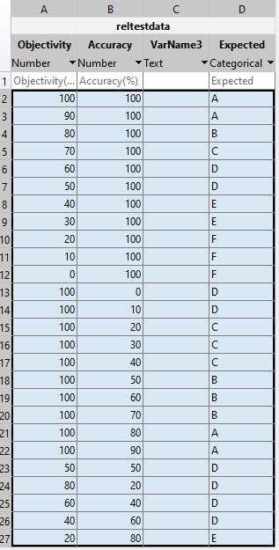

Figure 11 rel test data

# **Appendix D2.**

## Fuzzy inference system rel, triangular membership functions

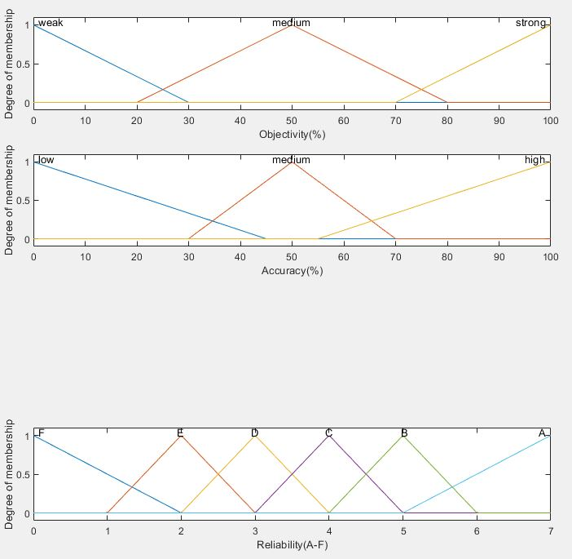

Figure 12 Fuzzy system configuration (trimf)

## Test output

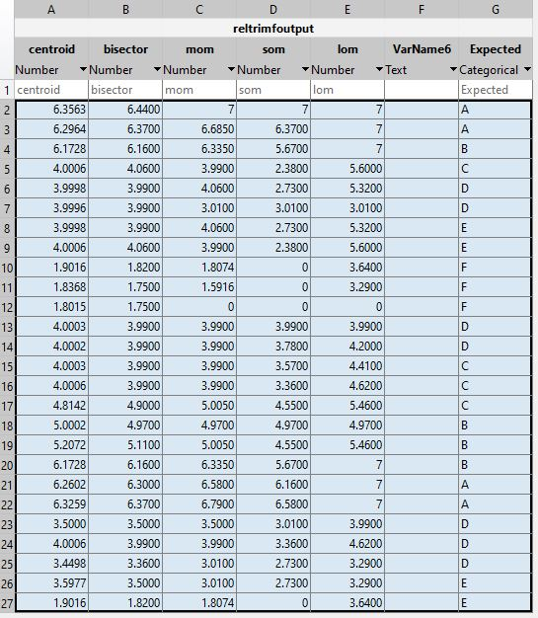

Figure 13 trimf test output data

## Defuzzification methods

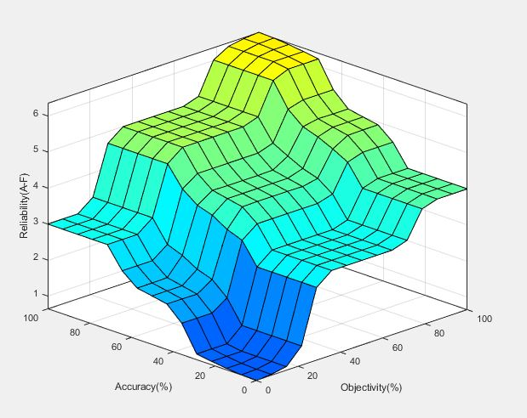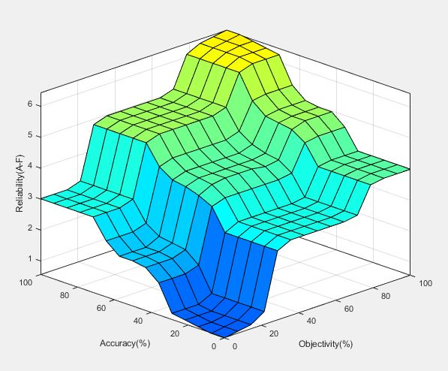

Figure 14 trimf test bisector Figure 15 trimf test centroid

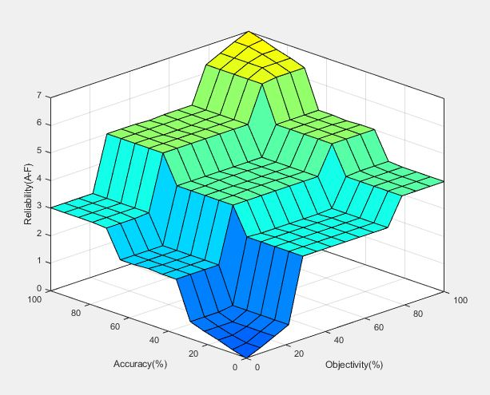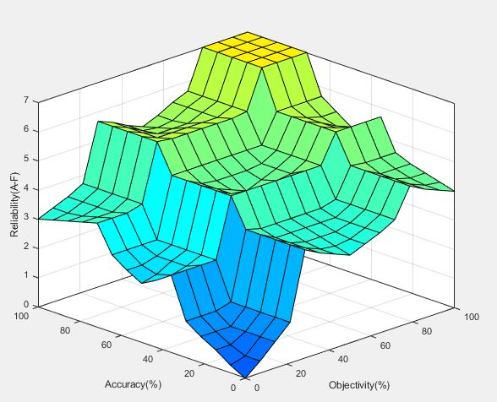

Figure 16 trimf mom Figure 17 trimf lom

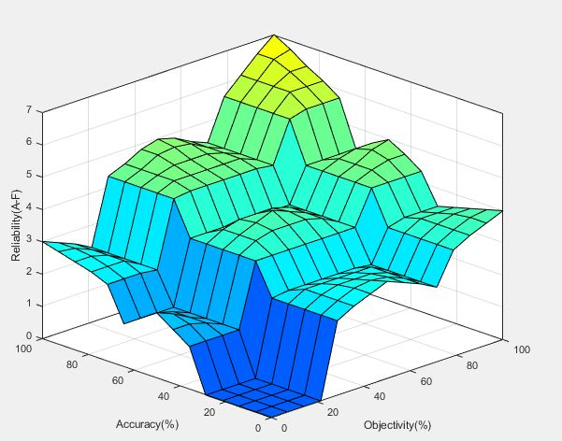

Figure 18 trimf som

# **Appendix D3.**

## Fuzzy inference system rel, trapezoidal membership functions

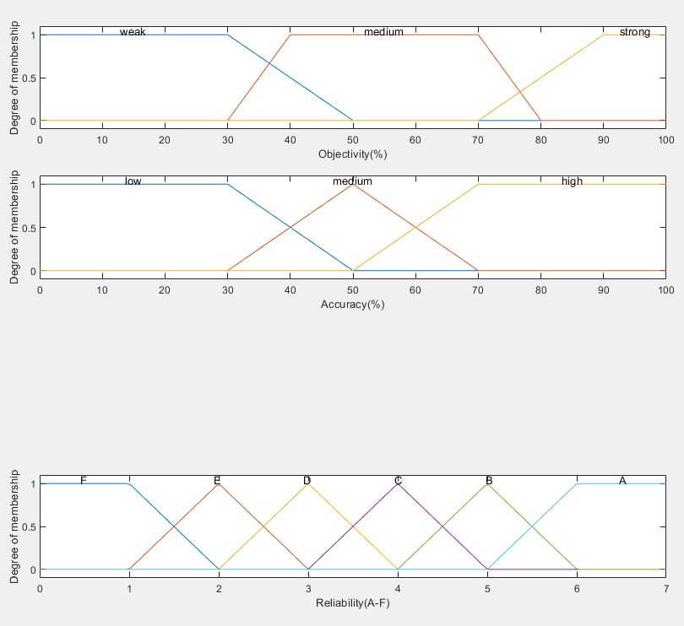

Figure 19 trapmf fuzzy inference system rel

## Test output

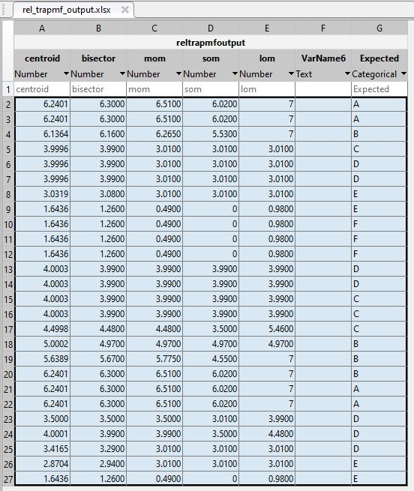

Figure 20 trapmf test output data

## Defuzzification methods

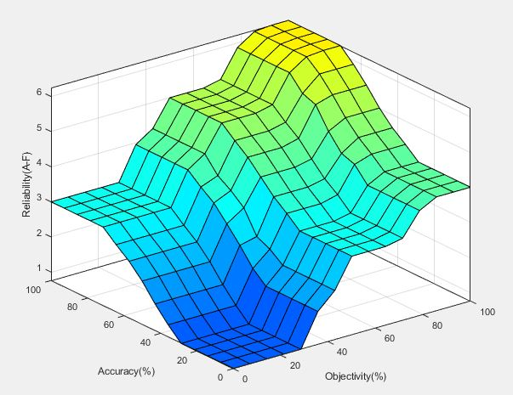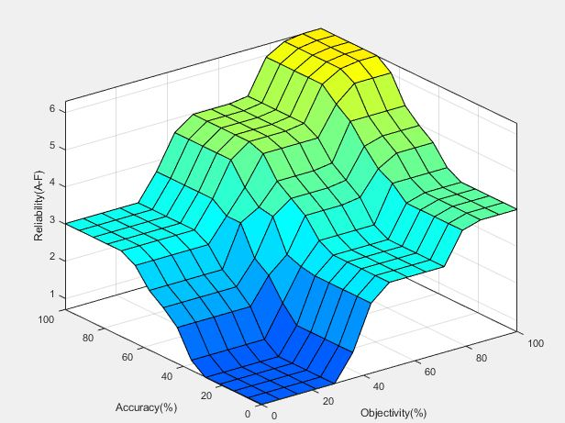

Figure 21 trapmf centroid Figure 22 trapmf bisector

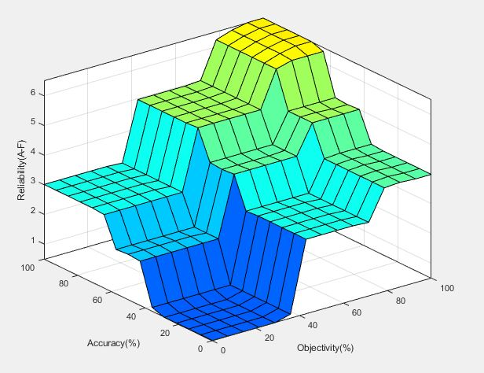 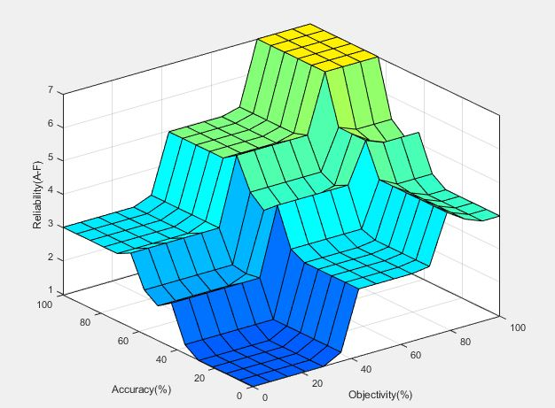

Figure 23 trapmf mom Figure 24 trapmf lom

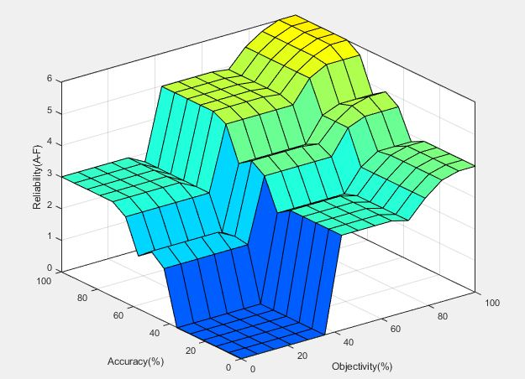

Figure 25 trapmf som

# **Appendix D4.**

## Fuzzy inference system rel, gaussian membership functions.

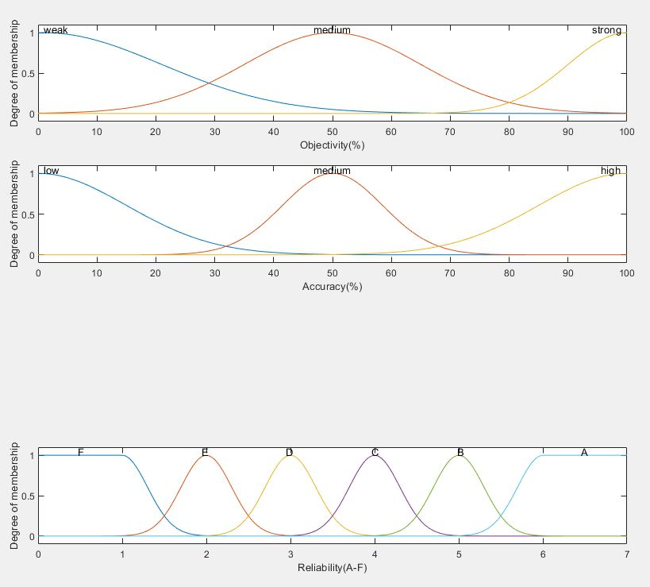

Figure 26 gaussmf fuzzy inference system rel

## Test output

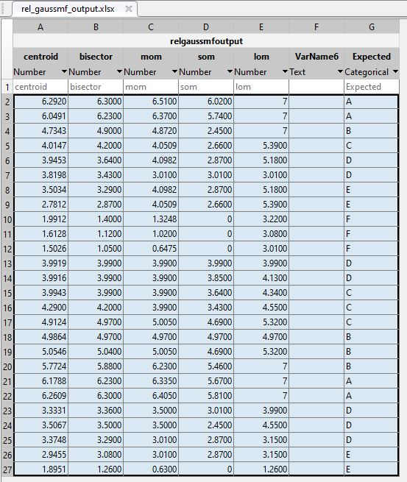

Figure 27 gaussmf test output data

## Defuzzification methods

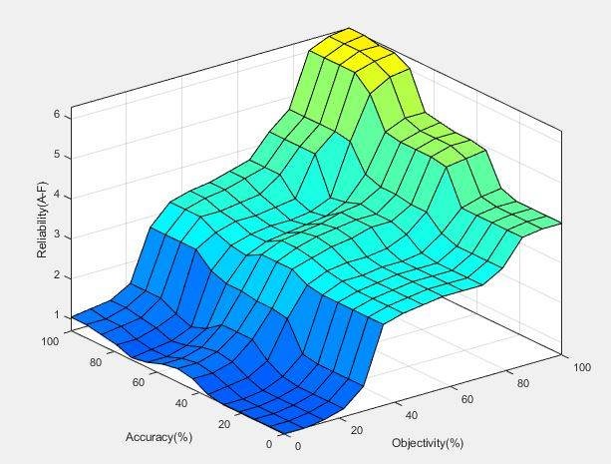

Figure 28 gaussmf centroid Figure 29 gaussmf bisector

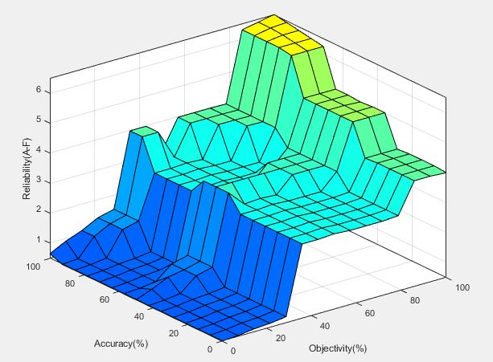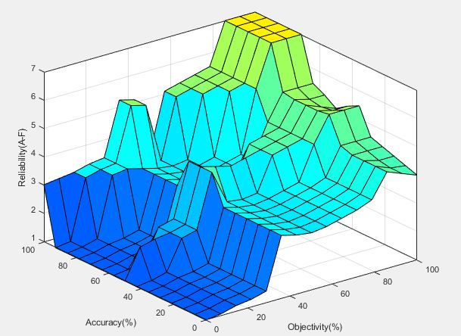

Figure 30 gaussmf mom Figure 31 gaussmf lom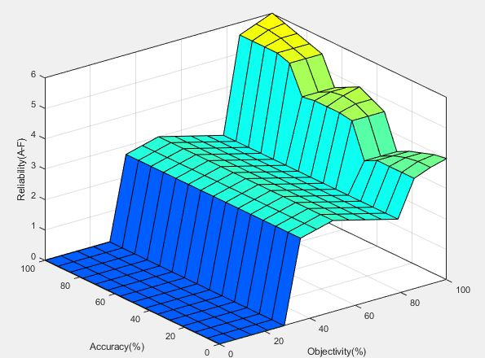

Figure 32 gaussmf som

# **Appendix D5.**

## Fuzzy inference system rel generalized bell-shaped membership functions.

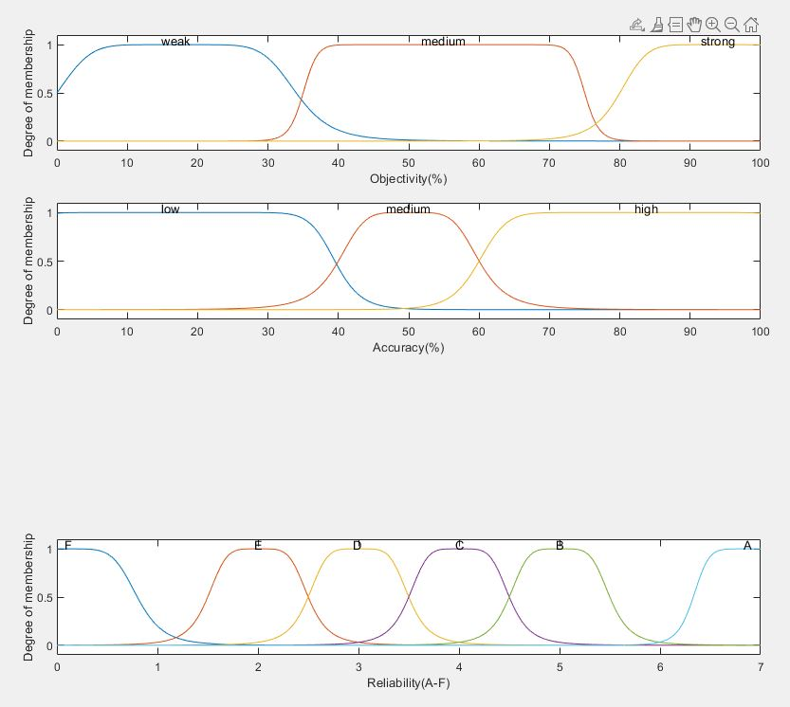

Figure 33 gbell fuzzy inference system rel

## Test output

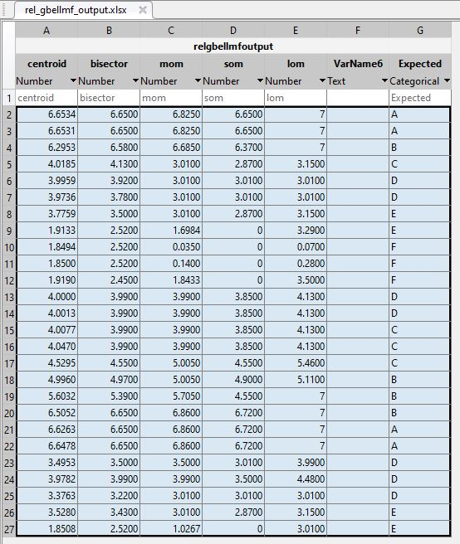

Figure 34 gbell test output data

## Defuzzification methods

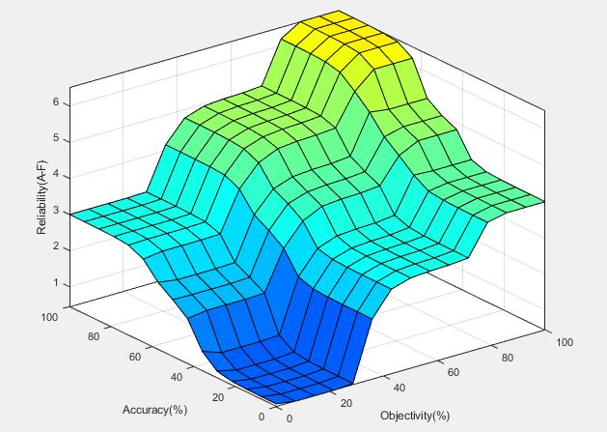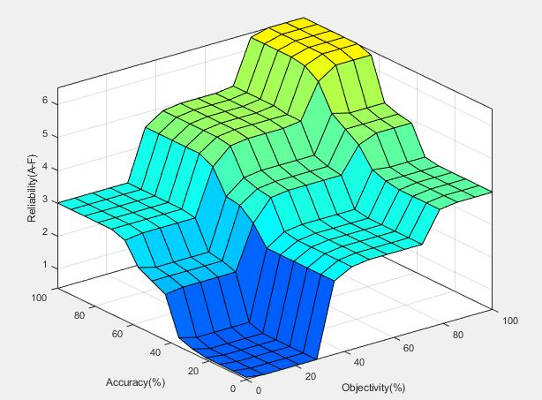

Figure 35 gbell centroid Figure 36 gbell bisector

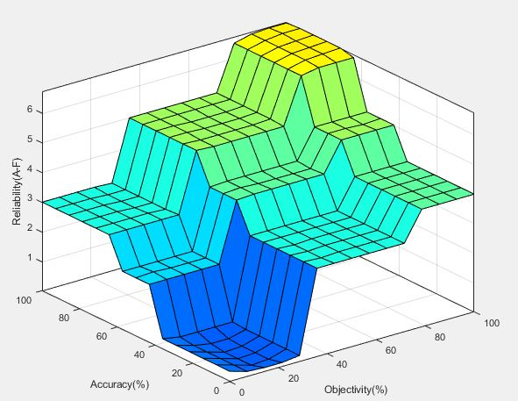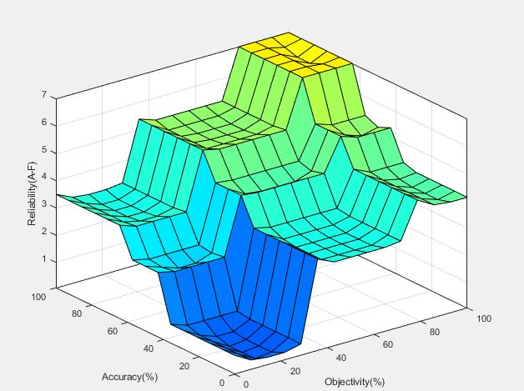

Figure 37 gbell mom Figure 38 gbell lom

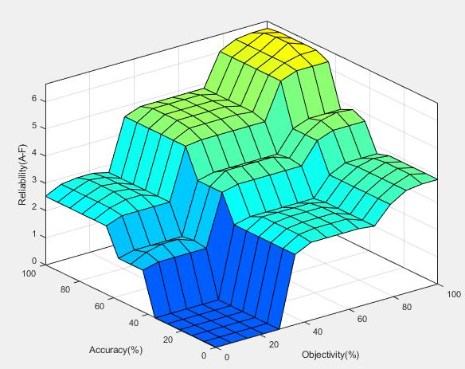

Figure 39 gbell som

# **Appendix D6.**

## Fuzzy inference system rel, triangular and trapezoidal membership functions.

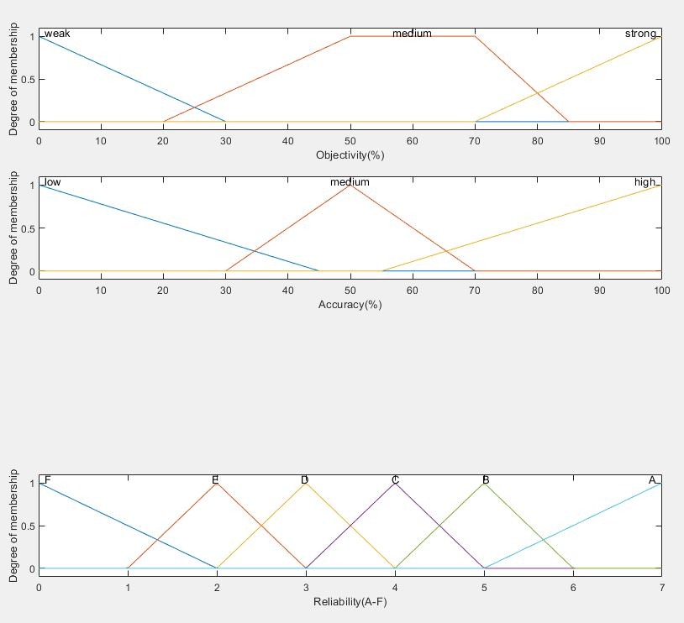

Figure 40 pointy fuzzy inference system rel

## Test output

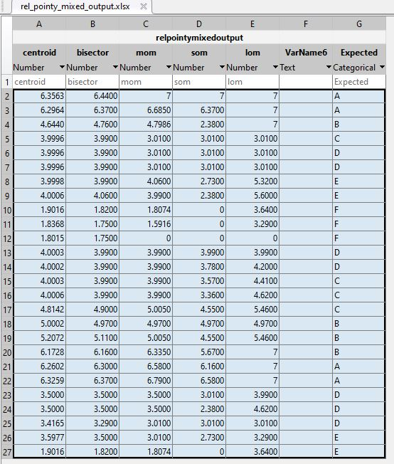

Figure 41 pointy test output data

## Defuzzification methods

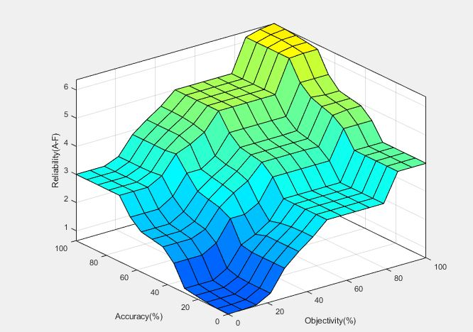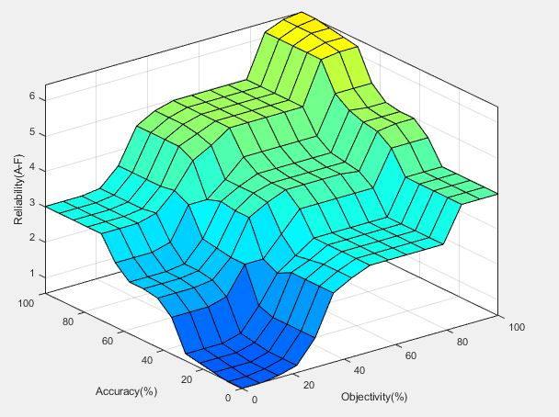

Figure 42 pointy centroid Figure 43 pointy bisector

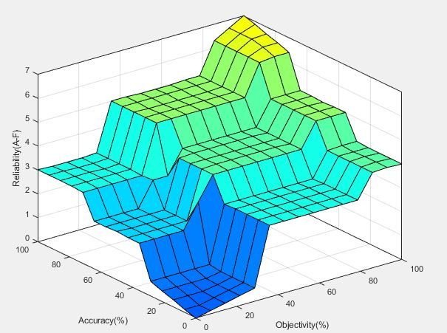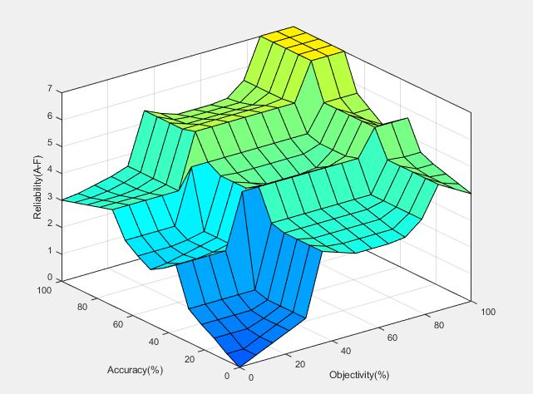

Figure 44 pointy mom Figure 45 pointy lom

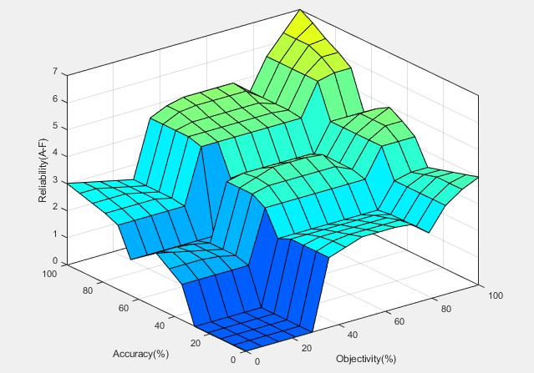

Figure 46 pointy som

# **Appendix D7.**

## Fuzzy inference system rel, gaussian and generalized bell-shaped membership functions.

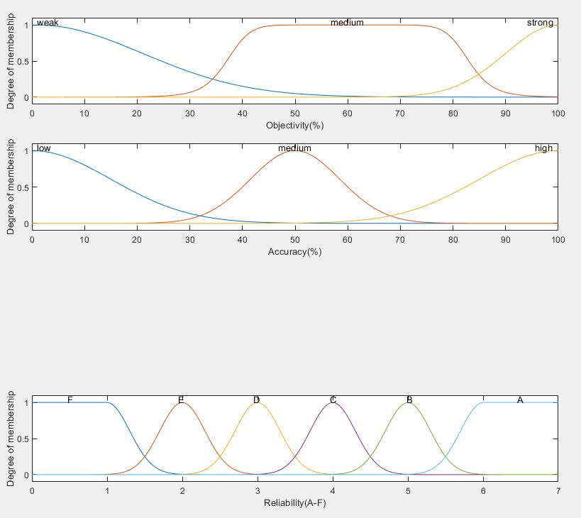

Figure 47 smooth fuzzy inference system rel

## Test output

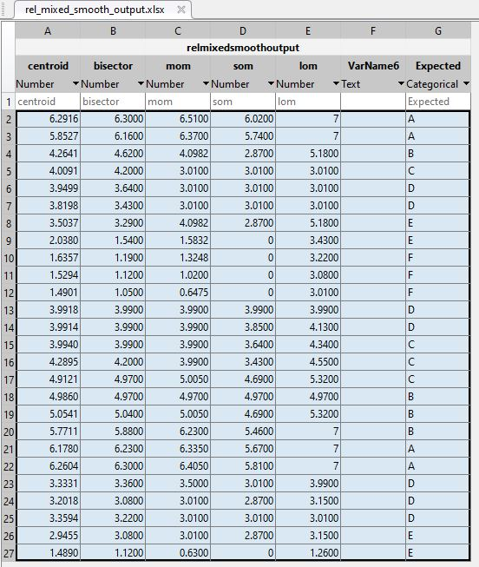

Figure 48 smooth test output data

## Defuzzification methods

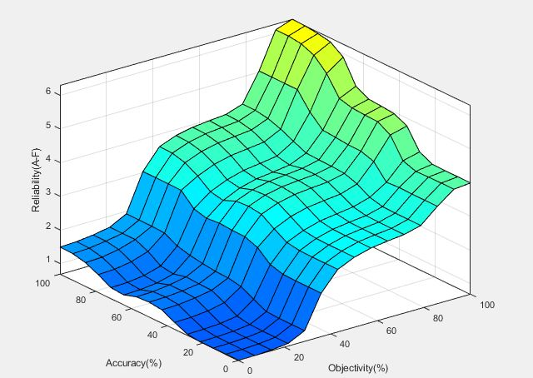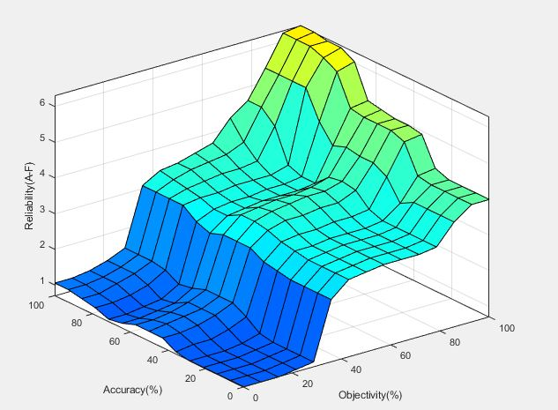

Figure 49 smooth centroid Figure 50 smooth bisector

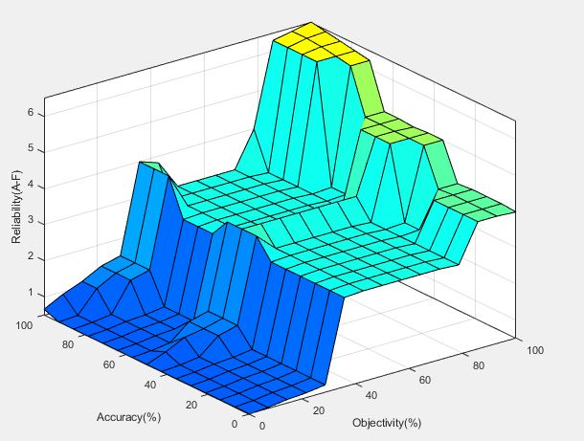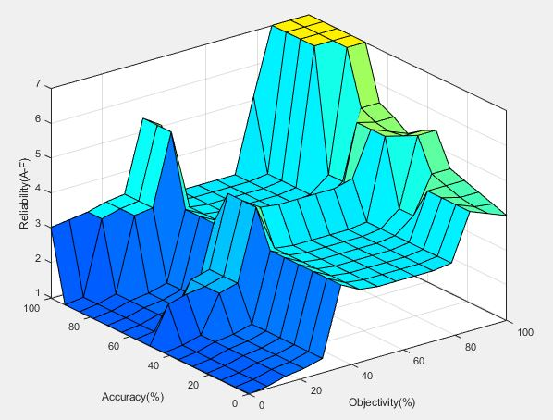

Figure 51 smooth mom Figure 52 smooth lom

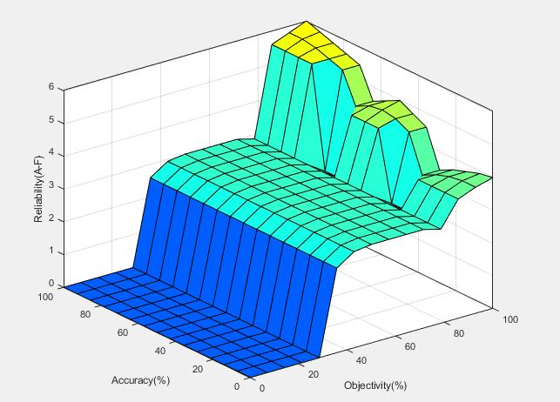

Figure 53 smooth som

# **Appendix E1.**

## Dummy data for FIS cred test scripts

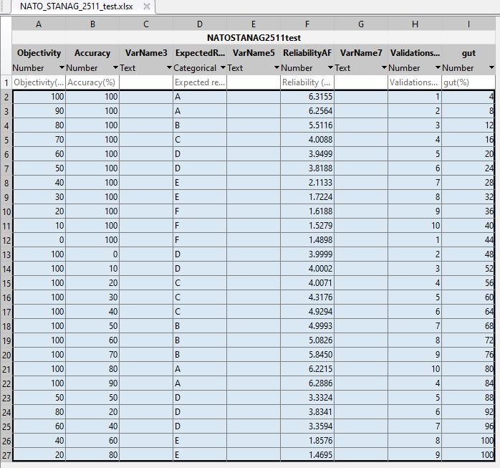

Figure 54 NATO_STANAT_2511_test.xlsx

# **Appendix E2.**

## Fuzzy inference system cred configuration of triangular membership functions

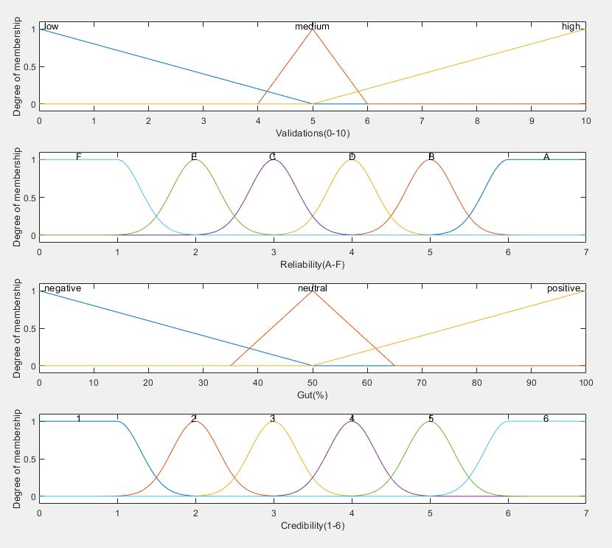

Figure 55 trimf fuzzy inference system cred

## Test output

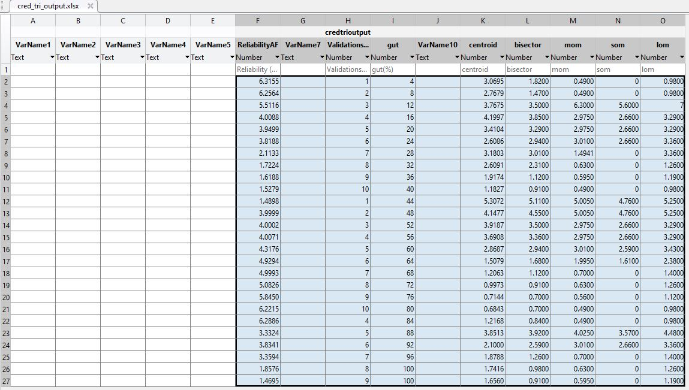

Figure 56 trimf cred test output data

## Defuzzification methods

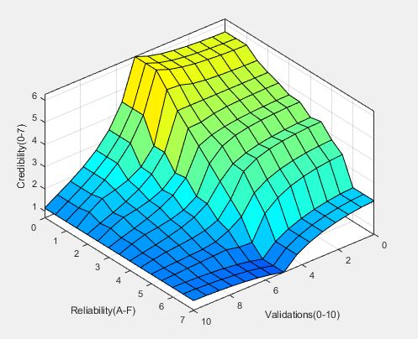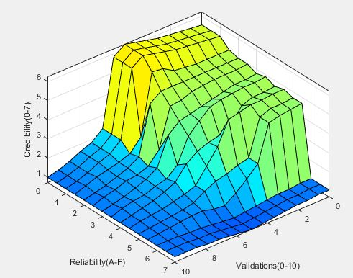

Figure 57 trimf centroid Figure 58 trimf bisector

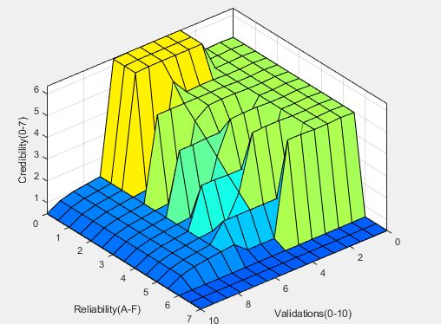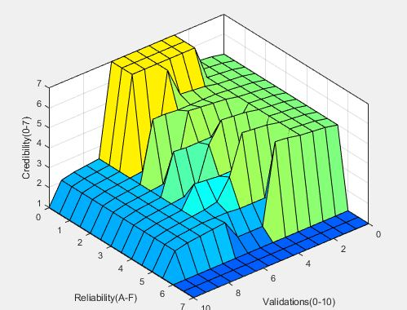

Figure 59 trimf mom Figure 60 trimf lom

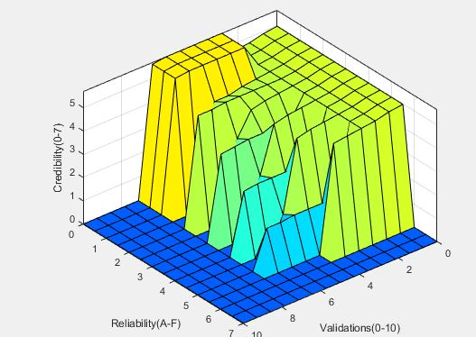

Figure 61 trimf som

# **Appendix E3.**

## Fuzzy inference system cred configuration of gaussian membership functions

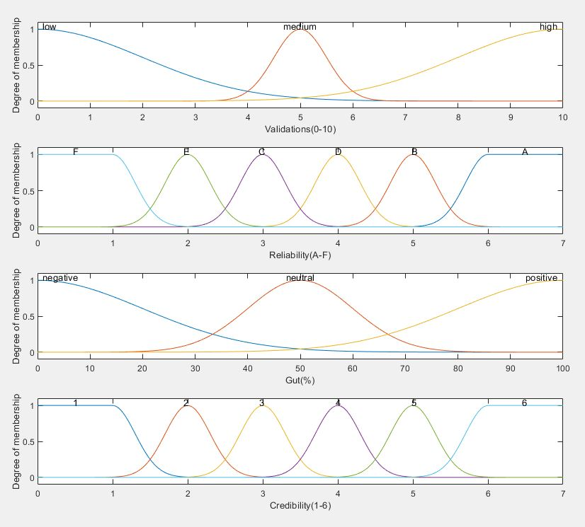

Figure 62 gaussmf fuzzy inference system cred

## Test output

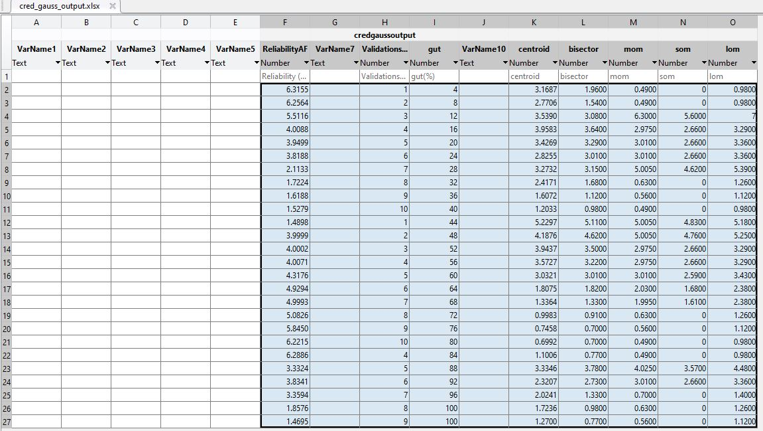

Figure 63 gaussmf cred test output data

## Defuzzification methods

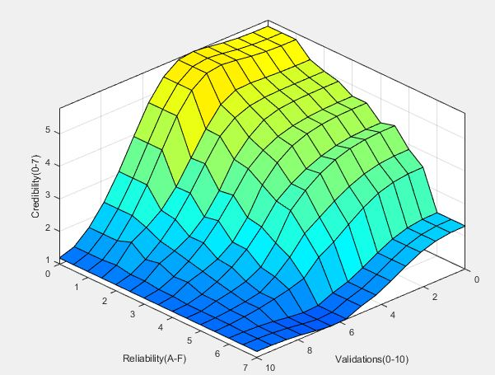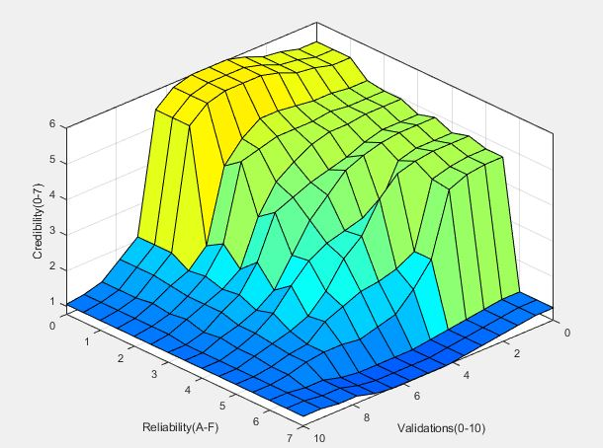

Figure 64 gaussmf centroid Figure 65 gaussmf bisector

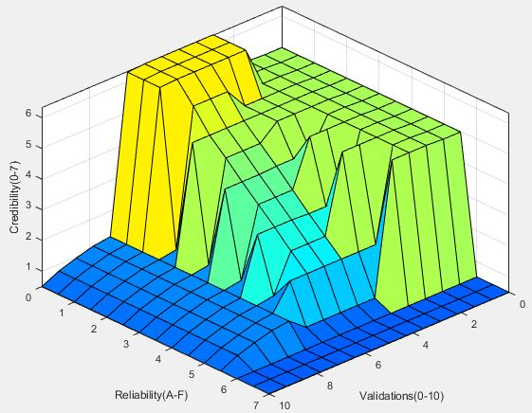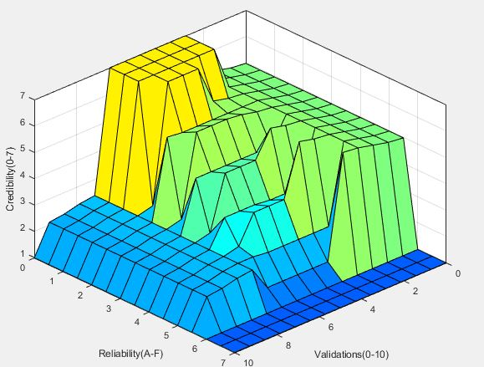

Figure 66 gaussmf mom Figure 67 gaussmf lom

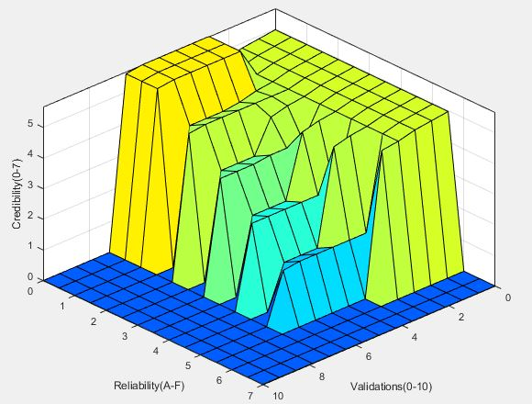

Figure 68 gaussmf som

# **Appendix E4.**

## Fuzzy inference system rel, triangular and trapezoidal membership functions.

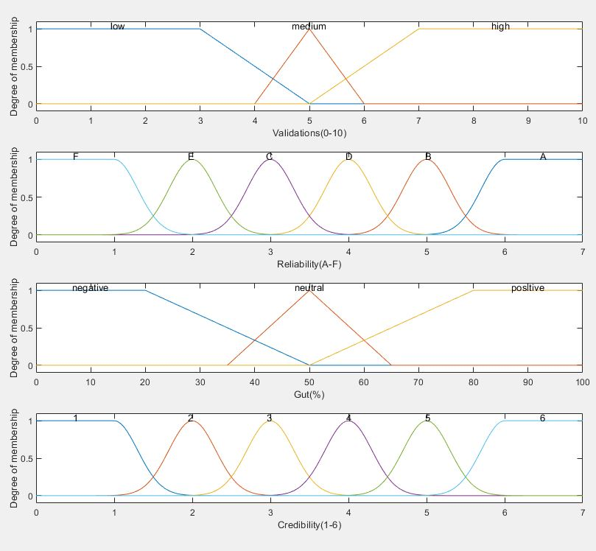

Figure 69 pointy fuzzy inference system cred

## Test output

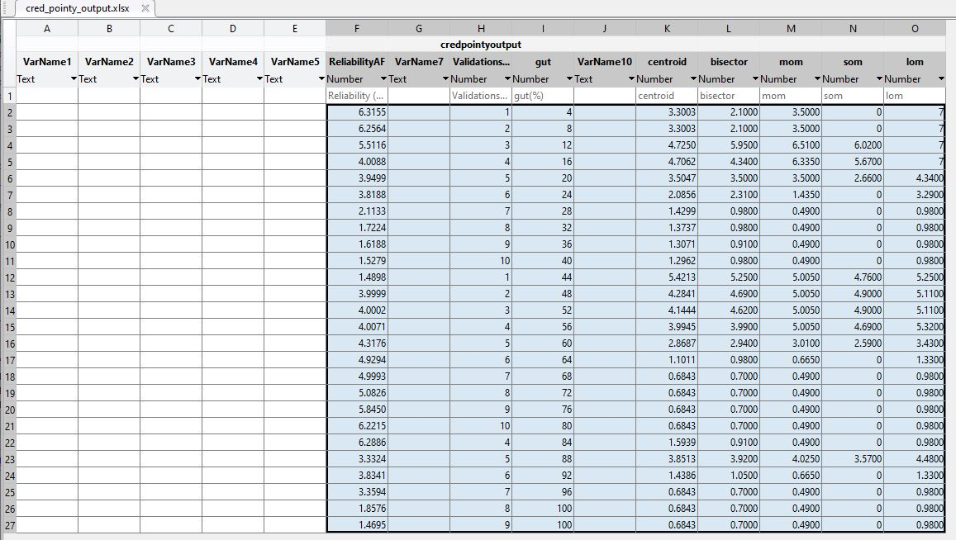

Figure 70 pointy cred test output data

## Defuzzification methods

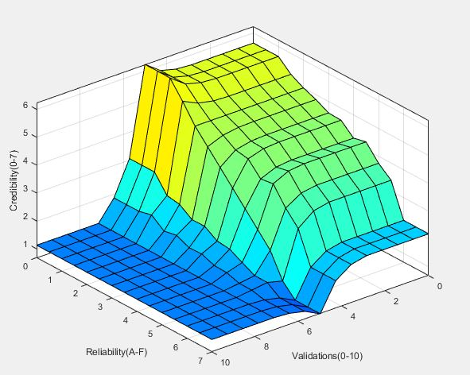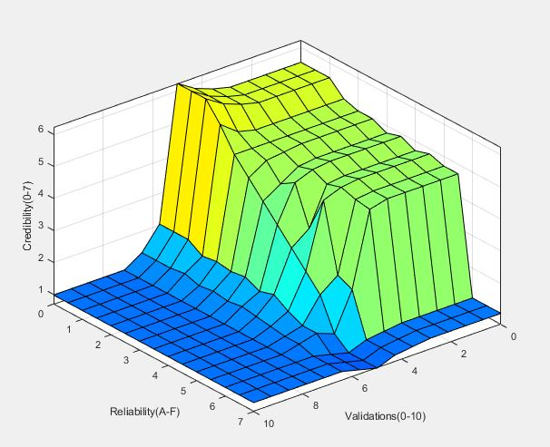

Figure 71 pointy cred centroid Figure 72 pointy cred bisector

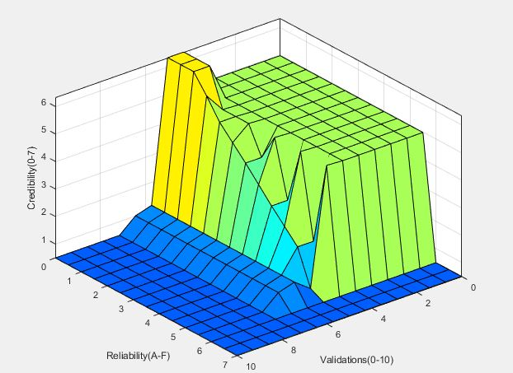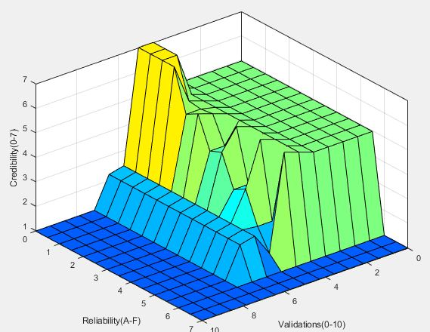

Figure 73 pointy cred mom Figure 74 pointy cred lom

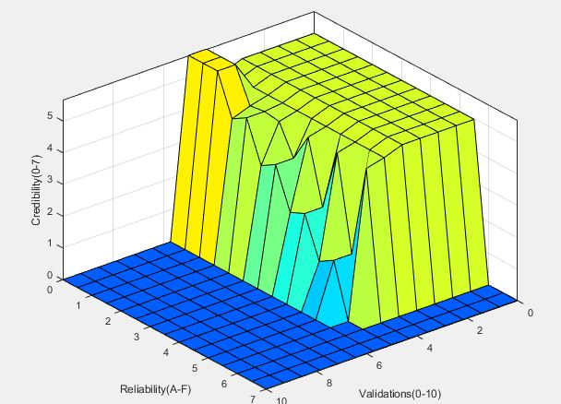

Figure 75 pointy cred som